PIERMONT ON THE MOVE : Taking Advantage of Designing for the Inevitable
Spitzer School of Architecture, the City College of New York/CUNY, Fall 2018

Ice Sheet in Greenland Melting Faster Than Ever Before Mon, 04/02/2018 - 3:36pm 9 Comments by Kenny Walter
https://www.nytimes.com/interactive/2018/04/20/sunday-review/climate-flood-quiz.html?mc=aud_dev&mcid=facebook&mccr=tafi20&ad-keywords=AudDevGate&subid1=TAFI&dclid=CPHRp87O9toCFZYNNwodRMoK8Q

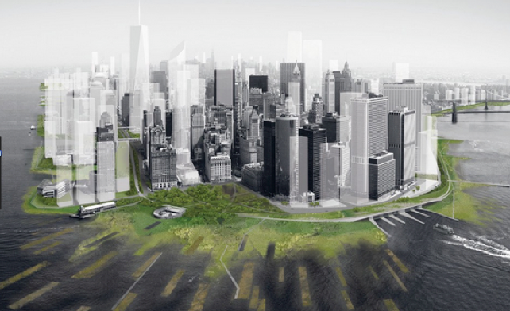
Protecting Lower Manhattan from sea level rise (SLR); The BIG U, BIG Architects

Type of Course: Advanced Studio
Course No.: Arch 47100(UG); Arch 85100 (G)
Class Meetings: M -Th: 2:00PM – 5:50PM (+ Thurs. 1-2pm Grad students Seminar)
Instructor: Lance Jay Brown

COURSE DESCRIPTION
In this Advanced Studio students from the 5th year B. Arch and 3rd year M. Arch and M.Arch II explore design together through the individual research interests of faculty. Emphasis is placed on design research and empowering students to identify & define design problems, establish evaluative criteria, analyze solutions, and predict the effectiveness of implementation. Students select studios through a lottery system on the first day of class.

THE PREMISE

The world is currently experiencing changes in the climate.
We are confronting an unprecedented environmental phenomena. The climate is changing at a previously unknown, unexpected, and accelerated rate. The reasons for the change are the subject of debate in some circles but the science shows that it is underway and that earth is only now recognizing and coming to grips with the serious and most likely dire implications. There is no shortage of research, popular discussions, symposia, articles, books, film and video media, and celebrities focused on what to do to slow climate change, respond to the climate change, adapt, and mitigate climate change, and assign blame and responsibility for it. The responsibility for the changes, while still debated in some circles, seem abundantly clear.

The causes for these changes are complex. How we choose to respond to these changes is increasingly a cause of constant concern and debate. In the midst of all the discussion and debate about what to do we find many “canaries in the coal mine”, many communities, towns, and even cities that are “holding the short straws”, that are truly at risk and/or even certainty of becoming a next Atlantis or ghost town..

In the extreme cases along the east coast of the United States from south to north Florida, the Carolinas, Norfolk, the Jersey Shore, and New York are among those most at risk. Internationally Bangladesh, Senegal, the South American west coast, numerous Pacific Islands (Tuvalu first among them), the Alaskan archipelago…. the list is long and of great concern. While some areas are at risk because of sea level rise (SLR) in other regions drought may be the threat, or lack of water, or extreme heat. Whatever the threat the risks assigned to climate change are real.

For some conditions there may be realizable practical solutions. However, in the long run we have a global problems that require global actions Among these are global population growth, diminishing sources of non-renewable energy, equitable distribution of resources, global migration, the effects of climate change on the planet, extraordinary accelerated emerging technologies, and the increased incidence of man-made and natural disasters.
No one source can reduce the increase in CO2 nor can one source mitigate the effect of the current conditions.

The Challenge

We are by no means the first to explore this issue. In many ways it is the story of civilization, an ever moving target of progress and the physical environment, the built environment, that accommodates and houses all human activity. However, our time has its own specifics and it is significantly different than all times before.

The design community writ large, architects, landscape architects, urban designers, industrial designers, inventors, an planners is hard at work on the issues outlined in the premise above. Our studio, in the short time allotted, will join in by investigating one location/community challenged by the advent of our changing environment. Working with a group of people involved in the post-Sandy northeast region we have identified a community that by all accounts will need to change because of the threat they are under.
This is a real challenge for them and a design challenge for us. To our knowledge this is not a normal undertaking. But in consultation with a broad range of engaged individuals it is a necessary one. We will early on have presentations by Architect and Landscape Architect Susannah Drake and others who have investigated this issue relative to the Rockaways in New York and other locations on the eastern seaboard.

The challenge to our studio is to carefully consider how we, the studio community, can participate in the transition that is before the community of Piermont New York, along the Hudson River.

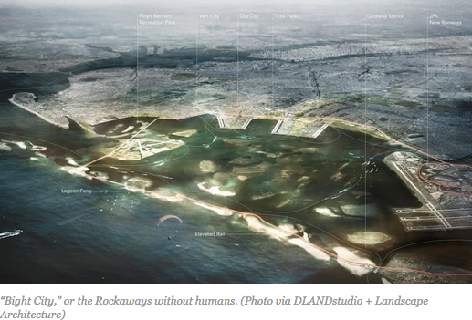 Moving the Rockaways across Jamaica Bay

Moving a Swedish town 2.5 miles away
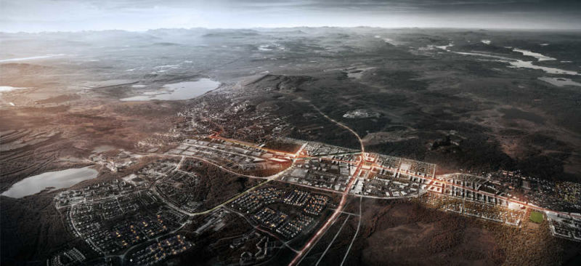

Kiruna, Sweden, GIZMODO/ 6 Cities and Towns That Were Relocated Completely: Reported widely online over the past few years, Kiruna is the northernmost town in Sweden—and it's currently caving in. Thanks to over-mining in the world's largest ore deposit, located directly below it, city officials are now tasked with moving the town, piece by piece, 2.5 miles east. The entire undertaking has already cost roughly $532 million—and that number is likely to double.

THE PROGRAM

This premise and challenge above will be engaged in the following ways.

Drawing from existing examples, previous studies, and real time experience separate teams of students will propose designs for how the town of Piermont, New York will respond to sea level rise and other evolving challenges of climate change and urbanization.

Each design will include the following :

(1) A vision statement that clearly states what their proposal will attempt to accomplish and over what phases during what period of time. It is assumed that this will be done with an actual client or a surrogate client that can help interrogate what the goals and objectives of the proposal will be.
(2a) An activity program that can reasonably serve to actualize the vision. The activity program should list the type, amount, and distribution of the people, things, and activities that the proposal will advocate for. This again should be informed by an actual or surrogate client and serve the needs of all the actors and users that will be involved. Program activities to be defined and public/private strategies as appropriate to the vision.
(2b) A space program that lists the size, amount, and distribution of all functional areas to be accommodated in the proposal. The use of case study templates and data can serve as a starting point for this phase. For each area listed there should be notation for special aspects as derived from analyzing the final space program.

(3) A systems program with infrastructural and environmental considerations that respond to program, context, site, climate, and maximum pursuit of net zero architecture. Aspects of new mobility, AVs, TODs, etc. to be considered.

(4) Designs should “test” the visions.

(5) Proposals to be presented in graphic and 3-D model forms and additional media as desired. All proposals shall scale from large scale to detail as necessary to present their ideas.

STUDIO CONSULTANTS/ CRITICS TEAM

The studio will have the benefit of input by people who have experience in the topic. The team list includes: Jeff Shumaker (NYC UD past director, now KPF), Alexis Taylor ex RBD noe NJ DEP), Thaddeus Pawlowski (past NYC UD now 100RC), Peter Cassok NY ED), Susannah Drake (DLand Studios), et al. Previewed studio reviewers include, David van der Veer (ED Van Alen), Johannes Knoops (Venice), Klaus Jacob (Columbia polymath), and the leadership of Piermont :
Bruce Tucker Mayor Village of Piermont Mayor & Trustee Email: btucker@piermont-ny.gov
Mark Blomquist Deputy Mayor Village Of Piermont Email: mblomquist@piermont-ny.gov
Ivanya Alpert Trustee Village of Piermont Email: ialpert@piermont-ny.gov
Rob Burns Trustee Village of Piermont Email: rburns@piermont-ny.govRob Burns has been a Piermont resident since 2009, and a Village Trustee since 2016. He currently serves on the Waterfront Revitalization Program, and before that, was on the Riverfront Resilience Task Force. He is also a member of the Piermont Community Garden and Vice President of the Paradise Homeowners Association.
Lisa DeFeciani Trustee Village Of Piermont Email: ldefeciani@piermont-ny.govLisa DeFeciani has been a Village Trustee since 2013. Born and raised in Haverstraw, she is a lifelong Rockland County Resident who has resided in Piermont for the past 13 years. As trustee, Lisa has taken an active role in Waterfront Resiliency, serving on the Local Waterfront Revitalization Program, the Resiliency Task Force, and as Chair of the Piermont Waterfront Resiliency Commission since 2016.
Jennifer DeYorgi Village Clerk Village of Piermont Email: clerk@piermont-ny.gov
Tom Temple DPW Supervisor Village of Piermont Email: TTemple@piermont-ny.gov
Charlie Schaub Building Inspector Village Of Piermont Email: Building@Piermont-NY.gov
Daniel Spitzer Chairperson: Planning Board Village Of Piermont desmdpc@mac.com
Usha Wright Chairperson: Zoning Board Village of Piermont Email: usha.wright@gmail.com

PROCESS and PRODUCT(S)
The studio will begin by establishing teams and informing itself of several determining parameters of the project. Each section of study will conclude with analytical graphic documentation and a presentation to the studio, which draw conclusions and speculations relevant to the particular project objectives and goals brief.

- Phase I: 8.27-9.20 (see Phase I below)
Immersion: Familiarization:: meeting with project experts, using existing relevant documents, data, and templates, and interviewing select residents, teams will create design programs. Information sharing is encouraged.
- Context and Site Analysis: A full scan of relevant characteristics and preparation of descriptive and analytical materials (history, morphology, figure/ground, plans and sections), see below:
- Preparation of case studies and precedents relevant to the project in general and to your own team’s context specifically. Relevant historical, classic, contemporary and proposed examples are acceptable. Analysis of the identified projects re scale, typology, complexity, function and aesthetics. Financial model, technical systems, and programmatic agility should be included.
- Phase II: 9.20-9.10.11
Visioning, Program preparation, and Conceptual designs, Programs will include a description of project actors, activities, and numerical and prose user requirements. Design programs should include a development time frame, see below
- Phase III: 10.15- 11.1
Design proposals
- Phase IV: 11.5-11.22
Design development
- Phase V: ….maybe 12.5 ???
Final Design Presentation

PHASE 1:
Team Research & Analysis

Basic Information and Data Collection
- Project background and information including:
- Project name
- Source of funding and budget
- List of program spaces (color coded) and square footages
- Location
- Interest groups and descriptions
- Work schedule and workbook and drawing format
- Position Paper: One page stating your position relative to the project and your goals

Context Description and Analysis
- Locational description at increasing scales [i.e. city, borough, neighborhood, area]
- Village and area description and analysis including:
- boundaries and catchment area
- circulation systems [distances, pedestrian, vehicular, public]
- land use – color-code using planning commission standard
- activity network – nodes, shopping, churches, community centers, transportation
- demographic considerations
- open space – village texture including height and bulk of buildings
- historic factors and forms [i.e. monuments, landmarks, etc.]
- zoning – macro and micro scales
- photos showing character of area and “sense” of the community

Site Description and Analysis and Model
- Detailed and graphic analysis of all natural and man-made forces which bear on the site and its immediate surrounding including:
- site and topographic information --series of the site (figure/ground studies, analysis of slopes, etc.)
- land use
- climatology, prevailing winds, sun orientation, degree-days, etc.
- services and utilities easements
- historic factors and forms (i.e. monuments, landmarks, etc.)
- subsurface conditions
- zoning – graphic analysis
- photos describing character and site and context
- A site model of appropriate scale should be constructed with provision for later study presentation of design alternatives. This model should be built in such a way that it can be used throughout the development of your project this semester and next.

Program Development and Analysis
- History of Project
- Need, perceived, actual
- interest groups [i.e. groups that can influence the design process]
- Program analysis including
- Detailed space description including user, activity and square footage description- to be color-coded with diagrams.
- Diagrams of space relationships graphically presented
- Detailed analysis of coding requirements for building type [graphic support material] in the form of user requirements
- Detailed analysis of the zoning requirements based upon the local zoning resolution. [In New York City these are separate documents; in other locations zoning and code requirements are combined].

Case Studies: Case Studies to consist of the following:
- Description of historical background and development of the project type; to be written and documented for presentation.
- Select one-primary and a minimum of two secondary examples of projects similar to your vision and which best describe the “state of the art” of the design of your project type. Projects hopefully include at least one site visit. If possible arrange an interview with an architect (preferably the one who designed the primary plan) who has done this type of project. You are encouraged to seek examples not only of projects similar to yours but other relevant examples (master plans/ pieces of buildings) with informative aspects.
- The graphic description and analysis is to include:
- location, date, name of architect
- site plans
- site relationships
- activity network -plan(s) (color code same as program analysis)
- square footages
- circulation
- technical/structure/ climate systems
- materials and construction
- façade/ skin treatment
- relevant historical significance
- photos and/or sketches of project
- relevant issues - design parameters for program
- energy and sustainability aspects of note
- budget

Phase II:Visioning/Conceptual Design Studies

Alternative Visions/Conceptual Designs
- Develop a minimum of three (3) completely different design alternatives. To be presented on large sheets [and to be included in final presentations]. Drawings should be color coded and should include:
- Vision/Concept diagrams
- Master/urban design plan
- plan(s)
- sections
- massing model on site

Phase III : Design Phase

Design Phase
Based upon the comments of the alternate vision/conceptual design phase, students and instructor will select one or some combination of solutions from the vision/conceptual phase as the basis for the design.

Phase IV : Design Development

Design Requirements
- Revise vision statement and conceptual diagrams that expand and explain your approach
- Village/District//Neighborhood/Design model with a mass model of proposal
- Completed final design model of project
- All plans [site, project, roof plan and/or grade floor plan] including surrounding context describing open space development
- Massing and Elevations - elevations are optional and may be fairly abstract. You may render, with shadows and colors [if you wish], showing materials only if critical.
- Analytical and critical sections - as many as required to explain your solution.
- Perspectives/Axonometrics / perspectives of design and major moments [may be hand drawn].

Phase V: Final Presentation

Design Presentation Requirements

- All appropriate background information prepared including: maps, village map, site/context analyses, program case studies, design alternatives, study models
- Conceptual diagrams that explain your approach and statement [statement is optional]
- Village/Neighborhood model with a mass model of solution
- Completed final design model of project along with the context / neighborhood model
- Site Plans [roof plan and/or grade floor plan] including surrounding context describing open space development
- Plans - Grade plan with developed context.
- Massing and Elevations - elevations are optional and may be fairly abstract. You may render, with shadows and colors [if you wish], showing materials only if critical.
- Sections - as many as required to explain your solution.
- Perspectives/Axonometrics / perspectives of design and major spaces [may be hand drawn].

Studio Schedule/ Activities
________________________________________________________________________

Phase I: 8.27-9.12

First Week 8/27 -30 /2016
Studio Introductions
Semester Design Research Project Introduction
Team Formation and Site Assignments
Review of Literature and resources

Second Week (9/3 no studio) 5,6/2018
Program Development
Context and Site Analyses
Case Studies Selection and Analyses (2 per Team
with a uniform studio outline for analysis for issues
to be asked and answered).
9/5 CLIENT/SITE VISIT
9/6 Susannah Drake presents/discusses

Third Week (9/10 no Studio) -9/13
Desk Crits

Fourth Week 9/17-9/20
Presentations
________________________________________________________________________
Phase II: 9.20-10.11

Fifth Week 9/24/-9/27
Vision/Concept Presentations

Sixth Week 10/1-10/4

Seventh Week (10/8 no class) 10/11
Design Proposals Presentations
________________________________________________________________________
Phase III: 10.15 - 11.1

Eighth Week 10/15-10/18

Ninth Week 10/22-10/25

Tenth Week 10/29-11/1
Design Proposals Presentations
________________________________________________________________________

Phase IV: 11.5 -11.22

Eleventh Week 11/5-11/8
Design Development

Twelfth Week 11/12-11/15
Design Development

Thirteenth Week 11/19- (11/22 NO CLASS)
Design Development Presentation
________________________________________________________________________
Fourteenth Week 11/26- 12.5 (11/24 – 11/27 College Closed, No Studio)
Final Presentation Preparation

Fifteenth Week 12/3-12/6
All Studio Presentations

READINGS, RESOURCES, REFERENCES

In Library

What Time Is This Place, Kevin Lynch
Design for Flooding, Donald Watson
The Agile City, James Russell
Design With Nature, Ian McHarg

Studio to develop a shared Google Docs folder with additional readings/references

POTENTIAL CASE STUDIES

Norfolk Resilience Strategy
Norfolk’s resilience strategy is driven by three key goals, each bolstered by supporting strategies and
actions. Some strategies and actions represent new initiatives, others are already underway. All are a
commitment to a new way of doing business—collective and coordinated action to build resilience
https://www.norfolk.gov/DocumentCenter/View/27257
https://www.norfolk.gov/DocumentCenter/View/16292

Mississippi Changing Course : Isle de Jean Charles
Waggoner and Bingler

Idlewild Watershed Communities New York Rising Community Reconstruction Plan | New York, US
https://www.louisberger.com/our-work/project/idlewild-watershed-communities-new-york-rising-community-reconstruction-plan
Challenge
During Superstorm Sandy, the communities of Springfield Gardens, Brookville and Rosedale experienced extreme tidal flooding. The lack of permeable surfaces within the communities led to rainwater runoff, causing overflows of the stormwater system and flooding in areas beyond the range of the tidal flooding. The communities also experience frequent stormwater flooding on a smaller scale during high tide events, heavy rainstorms, and nor’easters due to their low-lying topography, high groundwater table, and proximity to tidal wetlands.

White Architect’s Kiruna (sinking city)

Kiruna, Sweden, GIZMODO/ 6 Cities and Towns That Were Relocated Completely: Reported widely online over the past few years, Kiruna is the northernmost town in Sweden—and it's currently caving in. Thanks to over-mining in the world's largest ore deposit, located directly below it, city officials are now tasked with moving the town, piece by piece, 2.5 miles east. The entire undertaking has already cost roughly $532 million—and that number is likely to double.

Sweden Is Moving the Entire City of Kiruna Two Miles East - The Atlantic https://www.theatlantic.com/international/archive/2016/05/kiruna-sweden.../483521/ May 19, 2016 - How do you go about moving an entire city? That was the question the remote Swedish mining town of Kiruna faced in 2004 when its 18,000 residents learned that the ground below it was growing increasingly unstable. The city center sat on top of the world's largest iron mine………
Alaskan village votes in favour of relocating due to climate change
https://www.telegraph.co.uk/news/2016/08/17/alaskan-village-votes-on-relocating-due-to-climate-change/

Underdome
Fellows: Erik Carver and Janette Kim
Fellowship Term: Spring 2010
Project Area: Systems and Ecology Underdome stages debates between contending theories of energy efficiency to assess their design potentials for public life. During their residency, Carver and Kim focused on the initial research phases of the project, interviewing journalists, economists, advocates, ecologists, policy wonks, and engineers to map a spectrum of contrasting strategies for energy efficiency. Beyond the scope of the fellowship term, their work will lead to a series of debates and the publication of a guide to energy efficiency in the fall of 2010. Written for designers, this print and online manual will emulate a voter’s guide by evaluating competing models of efficiency and their implications.
Underdome assembles an expanded range of energy efficiency metrics – watts, profit, votes, ownership, leisure, health, and land use, to name a few – to generate a diverse set of criteria by which critical questions of energy policy might be evaluated. In a climate crisis, ask Carver and Kim, shouldn’t every option be on the table? In an emergency, shouldn’t we be ready to overhaul laws, economies and the built environment? Underdome speculates on the political ecology of energy in order to rethink familiar networks and spaces of the city.
The project is inspired by two proposals that redesigned relationships between buildings and power: Buckminster Fuller and Shoji Sadao’s 1960 Dome Over Midtown Manhattan and the 2009 American Recovery and Reinvestment Act (ARRA). Fuller and Sadao envisioned an infrastructure that would abandon existing development patterns for a radically new and efficient shared space, expanding climate control to the scale of the city, and redistributing the costs and benefits of architectural enclosure to a broader population. Today, the ARRA is allocating $20 billion for energy projects nationwide on the premise that collective public spending will lead to new efficiencies.

RESILIENT BRIDGEPORT: NATIONAL DISASTER
RESILIENCE AND REBUILD BY DESIGN PROJECTS, BRIDGEPORT, CONNECTICUT
FINALSCOPING DOCUMENT FOR THE ENVIRONMENTAL IMPACT STATEMENT
JUNE2018
https://resilientbridgeport.com/?mc_cid=9e8a5d0330&mc_eid
https://resilientbridgeport.com/wp-content/uploads/2018/06/Resilient-Bridgeport-Final-Scoping-Doc_June2018.pdf

New Orleans…what can we learn…

Sandy…what can we learn…

Babcock Ranch, FloridaBabcock Ranch is an innovative new town that sets a whole new standard for sustainable, responsible growth. Located in Southwest Florida just north of Fort Myers, Babcock Ranch combines the best of America’s great hometown traditions with all the conveniences of today and tomorrow. From the largest solar-plus-storage system operating in the U.S. today, the expansive public green spaces and trails to the gigabyte of fiber-optic connectivity standard to every home and and free wi-fi everywhere you may roam, it’s a place where families can benefit from the most advanced technologies, then walk out their doors to reconnect with nature and neighbors Babcock Ranch will ultimately include 19,500 homes and six million square feet of commercial space. Sustainability is at the core of everything we do at Babcock Ranch. From the building materials we use to the energy source that powers us and everything else in between, we’re minimizing our environmental footprint.
https://www.builderonline.com/building/building-science/floridas-babcock-ranch-a-city-powered-entirely-by-the-sun_o
Torti Gallas + Partners
1300 Spring Street Silver Spring, MD USA
301-588-4800Fax301-650-2255 new business Henry Harrell hharrell@tortigallas.com
Email contactmd@tortigallas.com

Houston City Council Unanimously Backs Plan to Build Homes in Floodplain
This story was not reported, edited or fact-checked by Architectural Record editors.
2018-04-25 Houston Chronicle
April 25 --Mayor Sylvester Turner and City Council , unanimously and without discussion, approved a developer's plan to build hundreds of homes in a west Houston flood plain Wednesday.The vote will let the developers create a municipal utility district to issue bonds to pay for roads, water, sewer and drainage infrastructure on the former Pine Crest Golf Course, where homebuilder Meritage Homes and land developer MetroNational plan to build some 800 homesVoting no would have denied the developers the ability to use the utility district as a method of financing construction, but would not necessarily have prevented the site from being developed.Meritage officials say the drainage system they are planning to build at the Spring Brook Village development will remove the 150-acre former golf course at Clay and Gessner from the 100-year floodplain, and will reduce stormwater runoff compared to what the site produces today.Some nearby residents are not convinced, and are concerned the development will put homeowners along flood-prone Brickhouse Gully even more at risk during storms.City estimates show Harvey damaged more than 2,300 homes and apartments in the Brickhouse watershed, and the city and county have bought out dozens of repeatedly flooded homes there.Meritage Homes is regrading the site, digging three detention ponds and a new channel to guide water through the site and into Brickhouse Gully . The excavated dirt will be piled elsewhere on the site and the new homes will sit on top of that soil, Meritage officials have said, with the lowest structure sitting 2.78 feet above the projected water level in a 500-year flood.That would exceed the new elevation standard -- two feet above the 500-year flood level -- that council adopted for development in floodplains earlier this month.A conditional letter from the Federal Emergency Management Agency states that the changes will greatly narrow the floodway on the site and remove the tract from the 100-year floodplain, placing it instead in the less risky 500-year floodplain.
The Memorial Day 2015, Tax Day 2016 and Harvey floods all reached or exceeded the 500-year standard, which refers to a storm that has a 0.2

Hibbing, MinnesotaTurns out there's precedent for Kiruna's debacle. In the late 1910s, the Minnesota town of Hibbing was relocated two miles south because of unstable ground—caused by the town's burgeoning iron mine. But unlike Kiruna, the people of Hibbing had far fewer resources to get the job done: Just horses, tractors, and and a steam crawler. And plenty of human hands, of course.
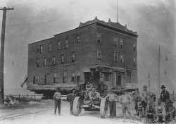
Image via MNOpedia via BLDGBLOG.Tallangatta, Australia https://cv.vic.gov.au/stories/a-diverse-state/tallangatta/tallangatta-the-town-that-moved/A more common reason to move entire towns? The construction of reservoirs and dams. Though governments usually end up paying inhabitants to abandon their homes in the face of a new dam, there are also a few examples of whole settlements being relocated. For instance, there's Tallangatta, a southern Australian town that was moved in the 1950s to make way for the expansion of the massive Hume dam.
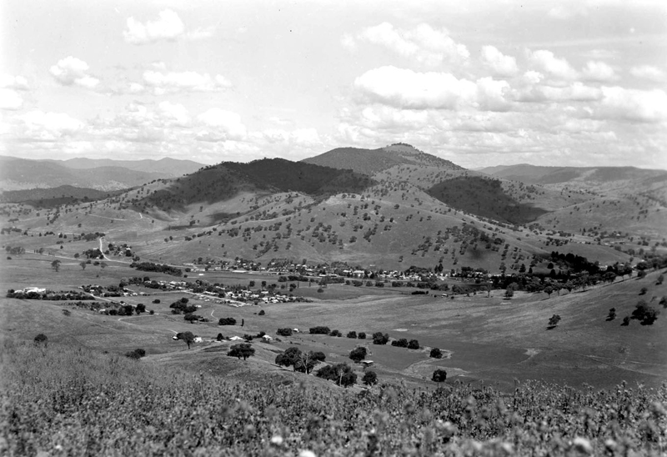

Galveston, Texas
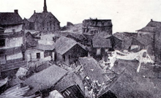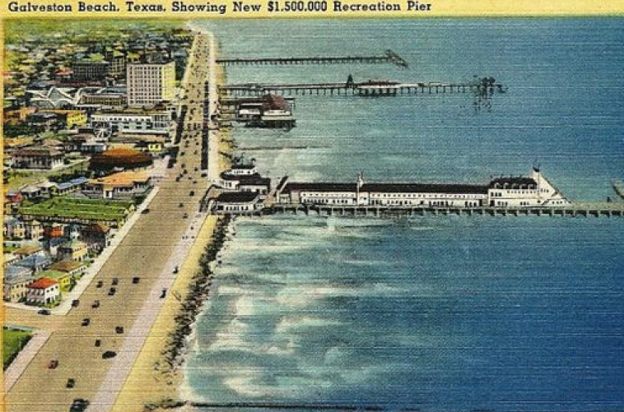
The Great Storm of 1900—aka the Hurricane of 1900—battered Galveston, Texas with Category 4 winds during what is still the deadliest hurricane in US history. But after the storm, some homeowners found an ingenious way to preserve what the could of their original homes—by raising them up on stilts and rebuilding whatever was underneath. According to Science Friday, some buildings were raised as high at 17 feet above their original foundations—and many took advantage of the change to add new porches and stairs to their homes. https://celebrating200years.noaa.gov/magazine/galv_hurricane/welcome.html
https://www.pinterest.com/pin/485262928575774101/?lp=
Minor Lane Heights, Kentucky
Residents of this small Kentucky town are part of an unprecedented deal with their local airport. In the mid-1990s, noise from the nearby jet engines forced many residents to consider taking cash to relocate. But instead, they struck up an unusual agreement: They'd let the regional airport buy the entire town (all 552 households, plus a police station) and move residents into a newly-built development five miles away, which mimicked the original in terms of design. That way, The New York Times explained, they could all stay together. Ironically, the new town is called Heritage Creek

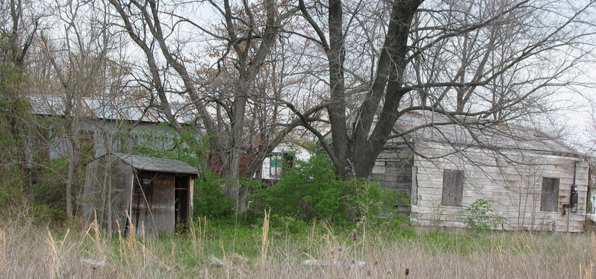

https://gizmodo.com/moving-mountains-six-cities-and-towns-that-were-comple-1436927345

Morococha, Peru
Morococha sits in the shadow of a mountain holding what may be the world's richest supply of copper—making it a prime target for metal-hungry miners the world over. Unregulated mining has left parts of the town a veritable toxic waste site—so when a Chinese mining conglomerate, Chinalco, took control, it set into motion a plan to move the entire settlement away from the site. According to ChinaFile, the New City of Morococha lies five miles away from the old toxic site—now being demolished.

GRADING & ATTENDANCE POLICIES AND STUDIO CULTURE

Course Requirements:

• Attendance and participation in class discussion in a constructive manner. Arriving more than ten minutes late will constitute an absence. Two unexcused absences will result in a whole letter grade deduction from your final grade; three will result in a failing grade.
• Participation in all reviews.
• Comprehension and discussion of assigned readings.
• Detailed project response and development in drawing, modeling, text, and design research.
• Successful completion of all project requirements and reviews is required and no make-up or postponed project submissions will be accepted except in the case of medical emergencies or other extraordinary circumstances. Excused absences and project delays must be officially cleared by professor in advance in order to be considered valid.
• Attendance to all Spitzer School of Architecture Sciame Lecture Series lectures. These lectures are mandatory and will be considered as part of your studio grade. Two unexcused absences from this series will result in a . letter grade reduction of your final studio grade.

Methods of Assessment:

• Attendance and participation in class discussions: 20%
• Project development in response to semester schedule: 50%
• Project presentation, completion and resolution: 30%
• Attendance to Sciame Lecture Series lectures. See policy above.

Studio Culture:

Working in the studio is mandatory. Studio culture is an important part of an architectural education. Please see the Spitzer School of Architecture Studio Culture Policy, which can be accessed on the SSA website here http://ssa1.ccny.cuny.edu/resources/p-g.html for more information.

Grading Criteria:
A (+/-) work meets all requirements and exceeds them. Presentations are virtually flawless, complete, and finely detailed. Work exhibits professional, “museum quality” level of craft. Student has developed an individual design process that shows a high level of independent thought and rigor. Work shows evidence of intense struggle to go beyond expectations, and beyond the student’s own perceived limits of their abilities.

B (+/-) work meets all requirements. Presentations are complete and finely detailed. Work exhibits professional level of craft. Student has developed an individual design process that shows a high level of independent thought and rigor.

C (+/-) work meets minimum requirements. While presentations may be complete, student has struggled to develop an individual design process and/or is lacking in craft or design resolution

D (+/-) work is below minimum requirements. Presentations are incomplete, student has struggled to develop an individual design process and/or is lacking in craft or design resolution.

F work is well below minimum requirements. Student does not develop adequate design process, and / or does not finish work on time.

INC grades of “incomplete” are not given under any circumstances unless there is evidence of a medical or personal emergency. Classes / work missed due to illness must be explained with a physician’s note.

Readings & Journals:

If and when readings are directly assigned, students are expected to have completed them before class. Students are also expected to keep a journal or sketchbook throughout the duration of studio to document their thought process. Students are also expected to take note during studio of any texts, books, terms or references that are mentioned by either the studio critic or fellow classmates and to selectively follow up on these.

Academic Dishonesty:

As a student you are expected to conduct yourself in a manner that reflects the ethical ideas of the profession of architecture. Any act of academic dishonesty not only raises questions about an individual’s fitness to practice architecture, but also demeans the academic environment in which it occurred. Giving or receiving aid in examinations, and plagiarism are a violation of an assumed trust between the school
and the student.

Plagiarism, i.e. the presentation as one’s own work of words, drawings, ideas and opinions of someone else, is a serious instance of academic dishonesty in the context as cheating on examinations. The submission of any piece of work (written, drawn, built, or photocopied) is assumed by the school to guarantee that the thoughts and expressions in it are literally the student’s own, executed by the student.

Office Hours:

Office hours are set by appointment. If you need to speak in private with your studio critic please email them in advance and request a meeting time.

Library:

The school’s library is a shared resource that is necessary supplement to all research and design work. Please direct questions to the library staff or the architecture librarian Nilda Sanchez

NAAB (National Architectural Accrediting Board)

The National Architectural Accrediting Board (NAAB) is the sole agency authorized to accredit US professional degree programs in architecture. Since most state registration boards in the United States require any applicant for licensure to have graduated from a NAAB-accredited program, obtaining such a degree is an essential aspect of preparing for the professional practice of architecture. While graduation
from a NAAB-accredited program does not assure registration, the accrediting process is intended to verify that each accredited program substantially meets those standards that, as a whole, comprise an appropriate education for an architect.

More specifically, the NAAB requires an accredited program to produce graduates who: are competent in a range of intellectual, spatial, technical, and interpersonal skills; understand the historical, socio-cultural, and environmental context of architecture; are able to solve architectural design problems, including the
integration of technical systems and health and safety requirements; and comprehend architects' roles and responsibilities in society.

The following Student Performance Criteria are addressed in this course:

Realm B: Building Practices, Technical Skills, and Knowledge. Graduates from NAAB-accredited programs must be able to comprehend the technical aspects of design, systems, and materials and be able to apply that comprehension to architectural solutions. In addition, the impact of such decisions on the environment must be well considered.

B.1 Pre-Design: Ability to prepare a comprehensive program for an architectural project that includes an assessment of client and user needs; an inventory of spaces and their requirements; an analysis of site conditions (including existing buildings); a review of the relevant building codes and standards, including relevant sustainability requirements, and an assessment of their implications for the project; and a definition of site selection and design assessment criteria. Realm C: Integrated Architectural Solutions. Graduates from NAAB-accredited programs must be able to demonstrate that they have the ability to synthesize a wide range of variables into an integrated design solution.

C.1 Research: Understanding of the theoretical and applied research methodologies and practices used during the design process.
C.2 Integrated Evaluations and Decision-Making Design Process: Ability to demonstrate the skills associated with making integrated decisions across multiple systems and variables in the completion of a design project. This demonstration includes problem identification, setting evaluative criteria, analyzing solutions, and predicting the effectiveness of implementation.

Students should consult the NAAB website www.naab.org for additional information regarding student performance criteria and all other conditions for accreditation.

