How to Login to ArcGIS Pro

Please consult your GIS instructors for information regarding access to ArcGIS software
- Open up ArcGIS as shown in Figure 1.
Figure 1: Location of ArcGIS on Desktop

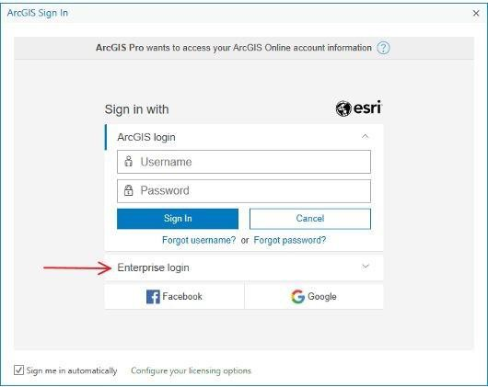
- On the login screen of ArcGIS, click on Enterprise login.
Figure 2: Login screen of ArcGIS

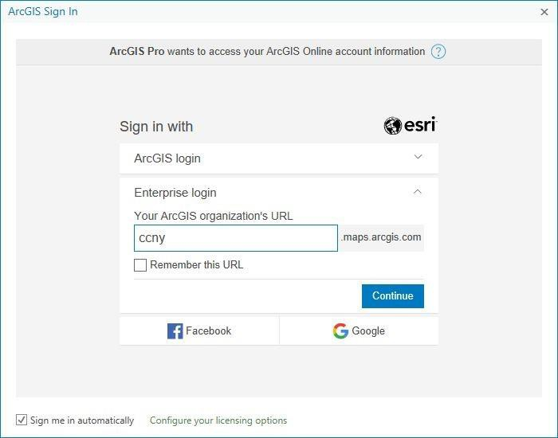
- After clicking on the Enterprise login, there will be an empty box in the whitespace under Your ArcGIS organization’s URL. Type in “ccny” without quotes and click on Continue. This is shown in Figure 3.
Figure 3: Enterprise Login

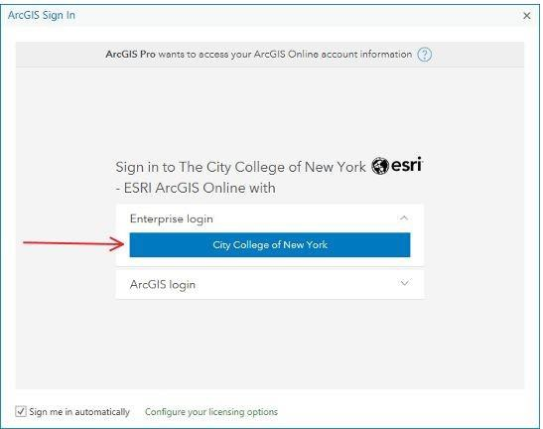
- Select City College of New York to continue.
Figure 4

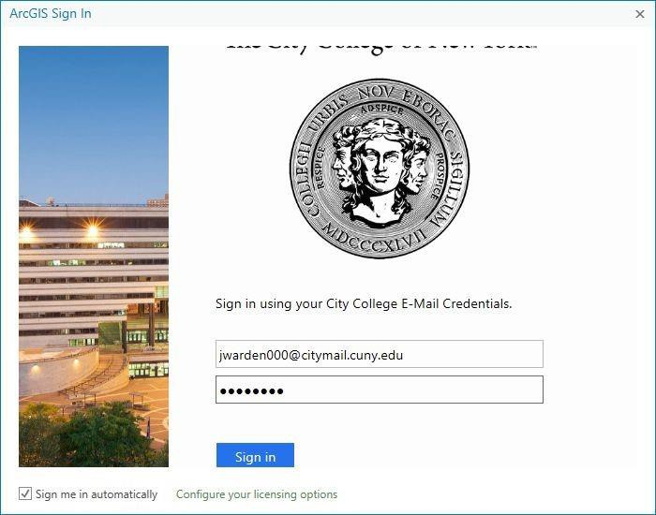
- The next window will prompt for CCNY credentials. Type in your CCNY email and password as shown in Figure 5, then click Sign in.
Figure 5: Prompt for City College Credentials

Note: If there are issues logging in, please make sure your password is typed in correctly. If issues continue to persist, reset your password at https://reset.ccny.cuny.edu/

