Type of Course: ARCH 51000 Advanced Studio
Class Meetings: M/TH 2:00-5:50pm
Office Hours: Alternating Wednesdays @ 12-2pm, Saturdays @ 11am-1pm
Instructor: Jelisa Blumberg
Location: [STUDIO ROOM]; some sessions on Zoom
Semester/Year Fall 2021

Portal Cities, City Of Portals*
*This is a DMU (Dark Matter University) affiliated course

“We looked for a table two chairs and some cups
We made a portable bookcase of brick and plank,
there we tied together Marx, the Bible, Mao Tse Tung,
the 20 Love Poems and a Song of Despair...” -Diana Morán

OVERVIEW

This studio will look at the entangled narratives of the Caribbean diaspora along with their neocolonial histories by investigating the lived hybridity evident in New York City and Panama City, Panama. In these cities we will search for small portals, digital and physical, between the two that exhibit a shared influence of livelihood and culture at both small scale urban conditions and larger, less frequent events that activate the street and neighborhood in both cities.

RESEARCH

The first portal in the relationship between the Caribbean and the U.S is the Panama Canal, cut through the Isthmus of Panama, marking the connection and severing the land bridge between the North and South American continents. The Panama Canal is emblematic of the U.S American colonial project in the Caribbean region and it’s construction can be seen as a geographic penetration. The social impact of this project increased migration of labor classes within the West Indies along with global migration from China and South Asian working class people. The confluence of culture, language, on a cultural hybridity and the sociopolitical trajectory that this project instigated can be felt all the way in Crown Heights Brooklyn.

PROGRAM
The primary program will be centered around hosting major events that have occurred in both Panama City and in New York City.

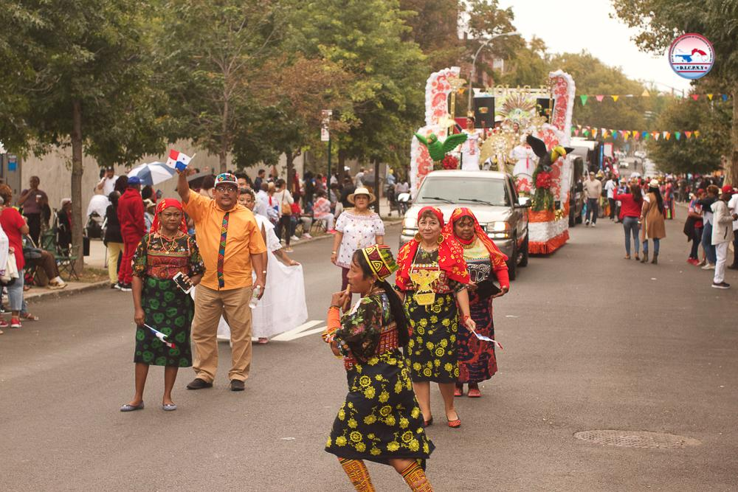

PROJECT 1 - Geographic Narrative Maps
Make a series of maps, inspired by Drexiya maps, that describe the geographic and cultural history of Panama, namely Panama City and its role in the Caribbean diasporic patterns and culture. Students will pull out key historical points and include a projective “future” map. Content of maps should be supported by key research.

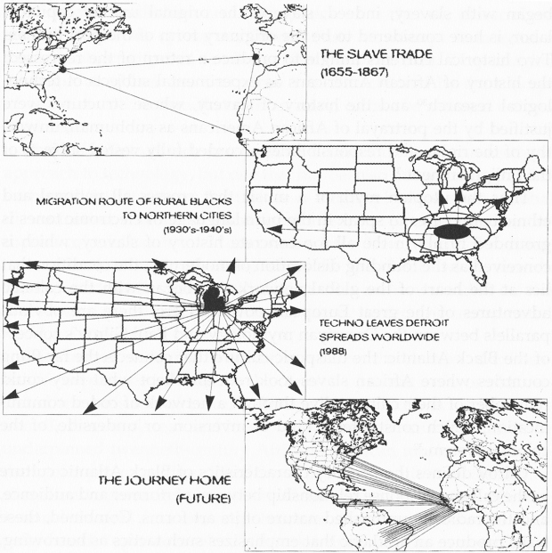

PROJECT 2 - Diagramming Culture
PROJECT 3 - Observe & Represent the Existing
PROJECT 4 - Portals

WEEKLY SCHEDULE, M/TH 2:00-5:50pm
Note: schedule below is subject to revision through the duration of the semester.
“Remote” days are in noted with an “R”

W1
Th 08.26 - R LOTTERY via ZOOM @ 12pm, followed by first studio meeting, including Hour SSA
Convocation @ 5:30pm
PROJECT 1 - MAPPING GEOGRAPHIC NARRATIVES
Introductions, Lecture, Discussion

W2
Mon 08.30 Studio
Th 09.02 Studio

W3
Mon 09.06 College Closed (Labor Day), no classes scheduled -
Th 09.09 - R Dark Matter University Talking Race Learn-In, 230p-5p

W4
Mon 09.13 Studio
Th 09.16 No classes scheduled

W5
Mon 09.20 Studio
Th 09.23 Studio

W6
Mon 09.27 Studio
Th 09.30 - R Studio

W7
Mon 10.04 Studio
Th 10.07 Studio

W8
Mon 10.11 College Closed (Columbus/Indigenous Peoples’ Day); no class
Th 10.14 - R Studio

W9
Mon 10.18 Studio
Th 10.21 Mid-semester assessments & Hour SSA

W10
Mon 10.25 Studio
Th 10.28 - R Studio

W11
Mon 11.01 Studio
Th 11.04 Studio

W12
Mon 11.08 Studio
Th 11.11 - R ADVANCED STUDIO SHARING via Zoom, @ 2:00-3:30pm; Studio

W13
Mon 11.15 Studio
Th 11.18 Studio

W14
Mon 11.22 Studio
Th 11.25 College Closed (Thanksgiving); no class

W15
Mon 11.29 Studio
Th 12.02 - R Studio

W16
Mon 12.06 Studio

REVIEWS
Wed 12.08 Advanced Studio reviews, session 1
Fri 12.10 Advanced Studio reviews, session 2
Tu 12.14 End of Semester Assessment (faculty only)

FINALS
Th 12.16 Final Class Meeting, Exit interviews
Mon 12.20 Student Portfolios due for: SSA/CCNY Archive, etc. as directed by instructor

Mon 12.27 Final Grade Submission Deadline

FINALS WEEK
Mon 12.14 Final Class Meeting, Exit interviews
Th 12.17 Student Portfolios due for: SSA/CCNY Archive, etc. as directed by instructor

GRADING/ATTENDANCE POLICIES AND STUDIO CULTURE

Course Expectations:
- That students will develop a high level of independent thought and rigor and a willingness to go beyond both basic project requirements and their own perceived limits and abilities.
- That students will successfully complete all project requirements. No make-up or postponed project submissions will be accepted except in the case of medical emergencies or other extraordinary circumstances. Excused absences and project delays must be officially cleared by professor in advance to be considered valid.

Community Agreement:
- During the first full studio meeting, the professor will make time for an Hour SSA session for a supportive open discussion among students.
- Studio members will work together to create a community agreement for interacting together over the semester. Definition: “A consensus on what every person in our group needs from each other and commits to each other in order to feel safe, supported, open, productive and trusting… so that we can do our best work.” https://www.nationalequityproject.org/tools/developing-community-agreements
- Hour SSA will be repeated at the middle of the semester.

Methods of Assessment:
- Attendance and participation in class discussions and other activities: 10%
- Project development in response to semester schedule: 60%
- Project presentation, level of completion and resolution: 30%
Note: The research component of the studio will be weighed more heavily in assessment of graduate student work and class performance, in cases where graduate students are enrolled in the studio.

Key areas of Grading Assessment:
- Studio performance & work habits: Ability to respond to studio discourse & feedback in a consistent & clear manner throughout the semester as demonstrated in the evolution and development of design work.
- Clarity of representation & mastery of media: Ability to utilize both digital and manual drawing and model-making techniques to precisely and creatively represent architectural ideas.
- Pre-design: Ability to prepare a comprehensive program for an architectural project that includes such tasks as: an assessment of client and user needs; an inventory of spaces and their requirements; an analysis of site conditions (including existing buildings); a review of the relevant building codes and standards, including relevant sustainability requirements, and an assessment of their implications for the project; and a definition of site selection and design assessment criteria.
- Research: Understanding of the theoretical and applied research methodologies and practices used during the design process.
- Integrated evaluations and decision-making design process: Ability to demonstrate the skills associated with making integrated decisions across multiple systems and variables in the completion of a design project. This demonstration includes problem identification, setting evaluative criteria, analyzing solutions, and predicting the effectiveness of implementation.
- Attendance: Consistent level of preparation and on-time presence for each studio class and scheduled evening lectures.
- Portfolio: Completion of final portfolio or collection of studio work as directed by instructor and/or coordinator and attendance at all scheduled portfolio related events.

Grading Criteria:

A (+/-) Work meets all requirements and exceeds them. Presentations are virtually flawless, complete, and finely detailed. Work exhibits professional, “museum quality” level of craft. Student has developed an individual design process that shows a high level of independent thought and rigor. Work shows evidence of intense ambition and effort to go beyond expectations, and beyond the student’s own perceived limits of their abilities.

B (+/-) Work meets all requirements. Presentations are complete and finely detailed. Work exhibits professional level of craft. Student has developed an individual design process that shows a high level of independent thought and rigor.

C (+/-) Work meets minimum requirements. Deadlines are missed. While presentations may be somewhat complete, student has struggled to develop an individual design process and/or is lacking in craft or design resolution.

D Work is below minimum requirements. Presentations are incomplete, student has struggled to develop an individual design process and/or is lacking in craft or design resolution.

F Work is well below minimum requirements. Student does not develop adequate design process, and/or does not finish work.

INC Grades of “incomplete” are not given under any circumstances unless there is evidence of a medical or personal emergency. In such cases, instructor and student develop a contract to complete work by a specified date, as per CCNY policy. Classes and/or work missed due to illness must be explained with a physician’s note.

Notes:
C is the lowest passing grade for M. Arch I and M.S. Arch students. D is the lowest passing grade for B. Arch students. No C- or D grades may be given to graduate students.
Working in teams does not guarantee the same grade for each team member; grades are based on a range of criteria for each individual student.

For more information on grading guidelines and other CCNY policies and procedures, consult the current
CCNY academic bulletins: https://www.ccny.cuny.edu/registrar/bulletins

Office Hours:
Each studio faculty member schedules 30 regular office hours over the semester, as posted at the top of the syllabus. If a student needs to speak in private with a studio critic, they should ask or email in advance to request a specific meeting time. Students may seek office hour appointments to discuss any matters of concern including personal, private matters and general inquiries about course related work, grading, assessment and content.

Probation & Dismissal: for program specific information related to grades, academic standing, probation and dismissal, please see your program academic advisors:
Undergrad: Michael Miller mmiller@ccny.cuny.edu
Amy Daniel adaniel@ccny.cuny.edu
Graduate: Hannah Borgeson hborgeson@ccny.cuny.edu

Studio Culture:
Working collaboratively and respectfully on studio assignments, with and alongside others, is an expectation in studio. Studio culture is an important part of an architectural education, and it extends to expectations for Faculty and the School’s Administration as well. Please see the Spitzer School of Architecture Studio Culture Policy, which can be accessed on the SSA website here: https://ssa.ccny.cuny.edu/about/policies/.

Absence & Lateness:
Arriving more than ten minutes late to class will constitute an absence. Two unexcused absences will result in a whole letter grade deduction from a final grade; more than four will result in a failing grade. It is expected that all students will participate in all scheduled working, midterm and final reviews and contribute constructively to the discussions.

Absences due to Religious Observances:
Students who will miss any class sessions, exams, presentations, trips, or the like due to a religious observance should notify the instructor at the beginning of the semester so that appropriate adjustments for observance needs can be implemented. This could include an opportunity to make up any examination, study, or work requirement that is missed because of an absence due to a religious observance on any particular day or days.

Readings & Journals:
Students are expected to keep a journal or sketchbook throughout the duration of studio to document their thought process & take notes of any texts, books, terms or references that are mentioned by either the studio critic or fellow classmates and to selectively follow up on these and any other assigned readings before the next class.

Academic Integrity:
As a student you are expected to conduct yourself in a manner that reflects the ethical ideas of the profession of architecture. Any act of academic dishonesty not only raises questions about an individual’s fitness to practice architecture, but also demeans the academic environment in which it occurred. Giving or receiving aid in examinations, and plagiarism are a violation of an assumed trust between the school and the student.

Plagiarism, i.e. the presentation as one’s own work of words, drawings, ideas and opinions of someone else, is as serious an instance of academic dishonesty in this context as cheating on examinations. The submission of any piece of work (written, drawn, built, or photocopied) is assumed by the school to guarantee that the thoughts and expressions in it are literally the student’s own, executed by the student. All assignments must be the student’s original work. Any copying, even short excerpts, from another book, article, or Internet source, published or unpublished, without proper attribution will result in automatic failure of the entire course.

The CCNY Academic Integrity Policy: https://www.ccny.cuny.edu/about/integrity

For citations, the Chicago Manual of Style is recommended: http://www.chicagomanualofstyle.org/tools_citationguide.html

AccessAbility Center (Student Disability Services):
The AccessAbility center (AAC) facilitates equal access and coordinates reasonable accommodations, academic adjustments, and support services for City College students with disabilities while preserving the integrity of academic standards. Students who have self-identified with AAC to receive accommodations should inform the instructor at the beginning of the semester. (North Academic Center 1/218; 212-650-5913 or 212-650-6910 for TTY/TTD). For further information, go to http://www.ccny.cuny.edu/accessability/ or email disabilityservices@ccny.cuny.edu

Health And Wellness Support:
City College’s Office of Health and Wellness Services offers free and confidential counseling. Contact: Health and Wellness Services, Marshak Science Building, room J-15: counseling@ccny.cuny.edu.

Gender Based Violence Resources
City College has resources to support you if you have experienced sexual violence, intimate partner/domestic violence, gender-based discrimination, harassment or stalking. For confidential support, you can contact the Student Psychological Counselor: Confidential Advocate at (212) 650-8905 or the Gender Resources Program at (212) 650-8222. If you would like to report sexual misconduct, you can contact the Chief Diversity Officer and Title IX Coordinator, Diana Cuozzo, at 212-650- 7330 or dcuozzo@ccny.cuny.edu. If there is an emergency on campus, you can call Public Safety at 212-650-777 and off campus call 911. Https://www.ccny.cuny.edu/affirmativeaction

Library:
The school’s library is a shared resource that is necessary supplement to all research and design work. Please direct questions to the library staff or the Architecture Librarian Nilda Sanchez-Rodriguez: nsanchez@ccny.cuny.edu

NAAB (National Architectural Accrediting Board):
The National Architectural Accrediting Board (NAAB) is the sole agency authorized to accredit US professional degree programs in architecture. Since most state registration boards in the United States require any applicant for licensure to have graduated from a NAAB-accredited program, obtaining such a degree is an essential aspect of preparing for the professional practice of architecture. While graduation from a NAAB-accredited program does not assure registration, the accrediting process is intended to verify that each accredited program substantially meets those standards that, as a whole, comprise an appropriate education for an architect.

More specifically, the NAAB requires an accredited program to produce graduates who: are competent in a range of intellectual, spatial, technical, and interpersonal skills; understand the historical, socio-cultural, and environmental context of architecture; are able to solve architectural design problems, including the integration of technical systems and health and safety requirements; and comprehend architects' roles and responsibilities in society.

The following student performance criteria from the 2014 NAAB Conditions are addressed in this course:

Realm B: Building Practices, Technical Skills, And Knowledge. Graduates from NAAB-accredited programs must be able to comprehend the technical aspects of design, systems, and materials and be able to apply that comprehension to architectural solutions. In addition, the impact of such decisions on the environment must be well considered.

B.1 Pre-Design: ability to prepare a comprehensive program for an architectural project that includes an assessment of client and user needs; an inventory of spaces and their requirements; an analysis of site conditions (including existing buildings); a review of the relevant building codes and standards, including relevant sustainability requirements, and an assessment of their implications for the project; and a definition of site selection and design assessment criteria.

Realm C: Integrated Architectural Solutions. Graduates from NAAB-accredited programs must be able to demonstrate that they have the ability to synthesize a wide range of variables into an integrated design solution.

C.1 Research: understanding of the theoretical and applied research methodologies and practices used during the design process.

C.2 Integrated Evaluations and Decision-Making Design Process: ability to demonstrate the skills associated with making integrated decisions across multiple systems and variables in the completion of a design project. This demonstration includes problem identification, setting evaluative criteria, analyzing solutions, and predicting the effectiveness of implementation.

Students should consult the NAAB website www.naab.org for additional information regarding student performance criteria and all other conditions for accreditation.

CONTACT INFORMATION:

Jelisa.blum@gmail.com

